- Create user with name Techie and provide sudo access to user.

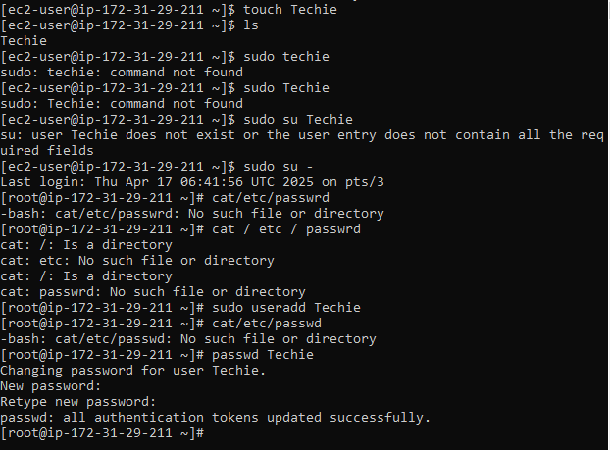

- Navigate to the home directory.

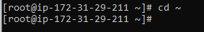

- Create a new directory.

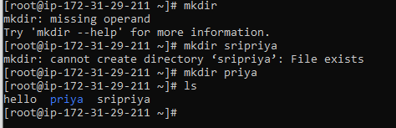

- List the contents of a directory.
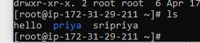

- Change the current directory.

- Create a new empty file.
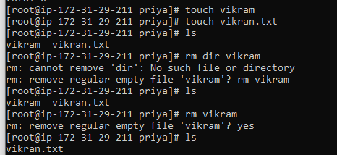

7)View the contents of a file.
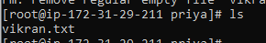

8)Copy a file to another location.

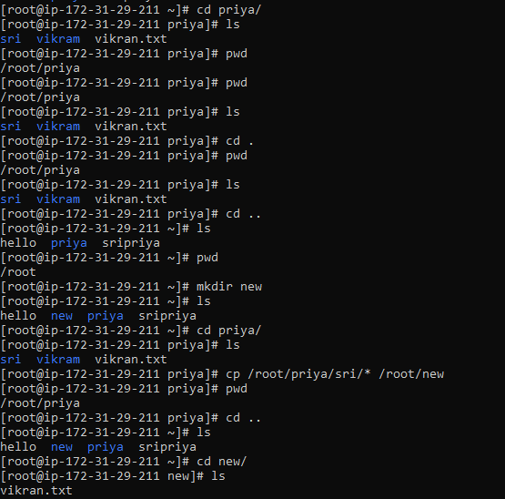

- Move a file to another location.
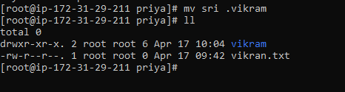

- Rename a file.
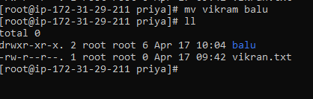

- Delete a file.
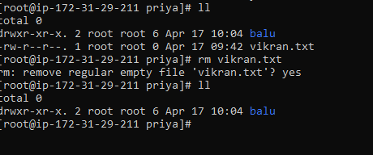

- Grant or revoke permissions on a file or directory.
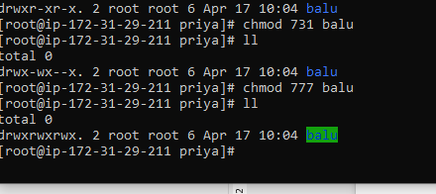
- View the current date and time.

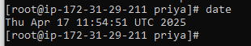

- Check the system uptime.

uptime command displays how long the system has been running, along with the current time, number of logged-in users, and system load averages

- View the running processes.
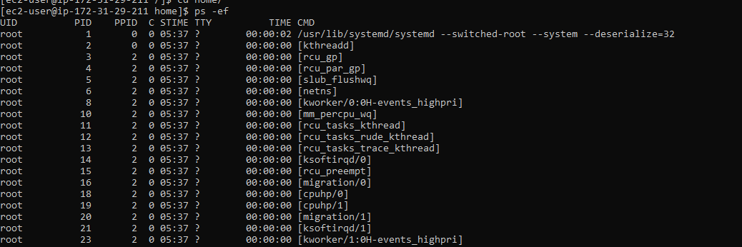

- Kill a running process.

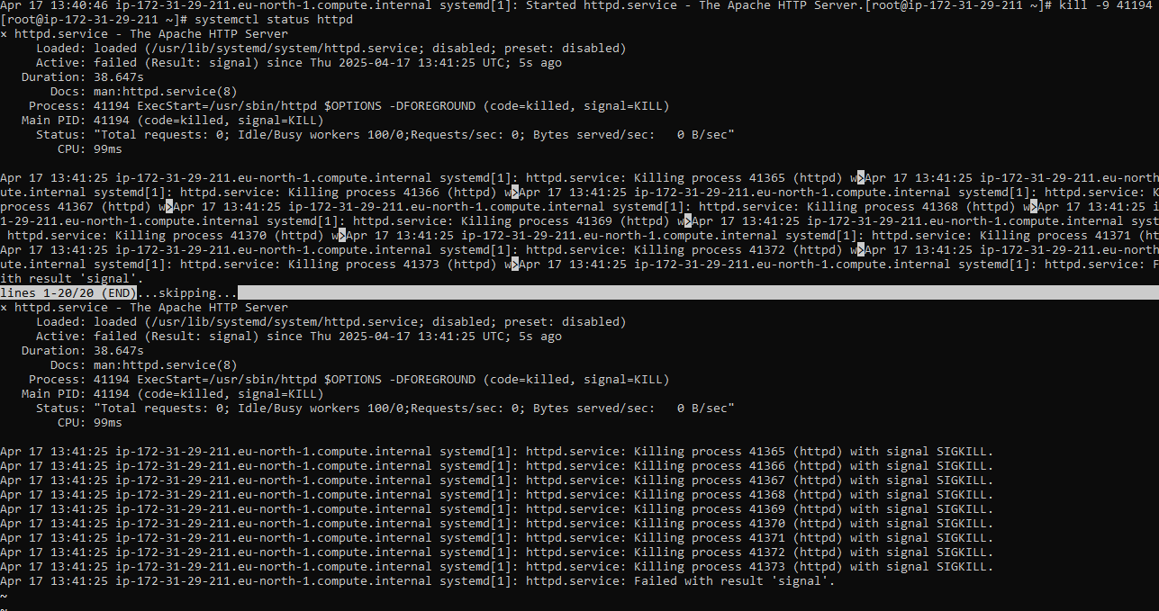

- Install a package using the package manager (e.g., apt or yum).
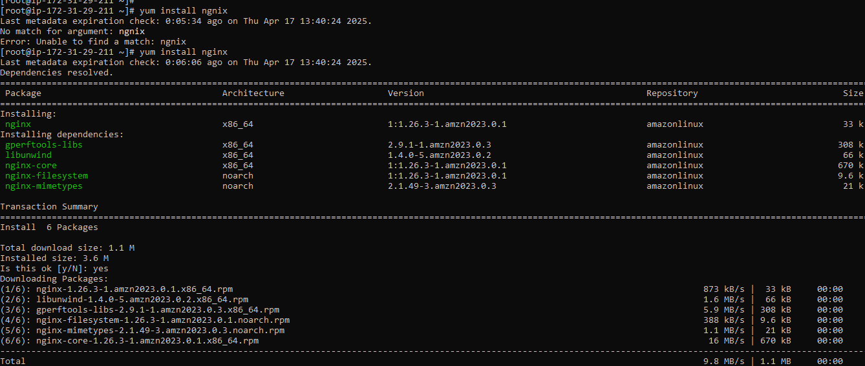
- Update the system packages.

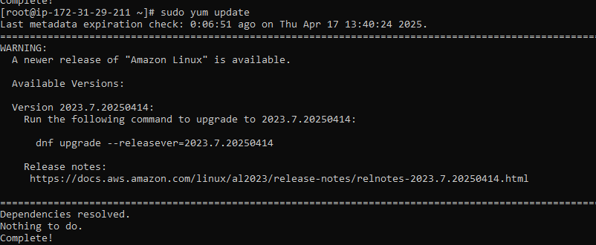
- Create a symbolic link.
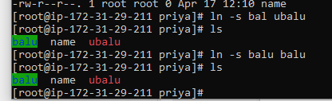

- Search for files using the find command.

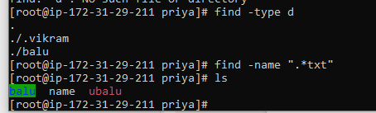
- Compress and decompress files using tar.

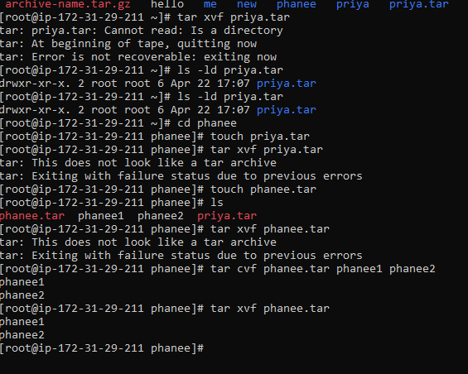
- Monitor system resources with top or htop.
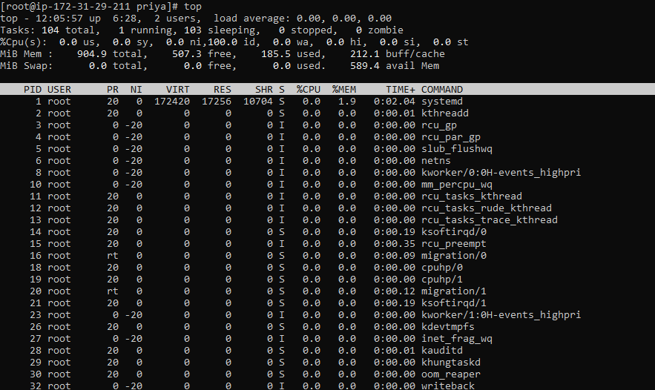
- Create and manage user groups.
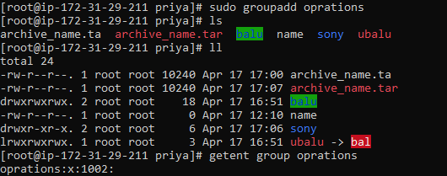
- Set up SSH password less authentication.

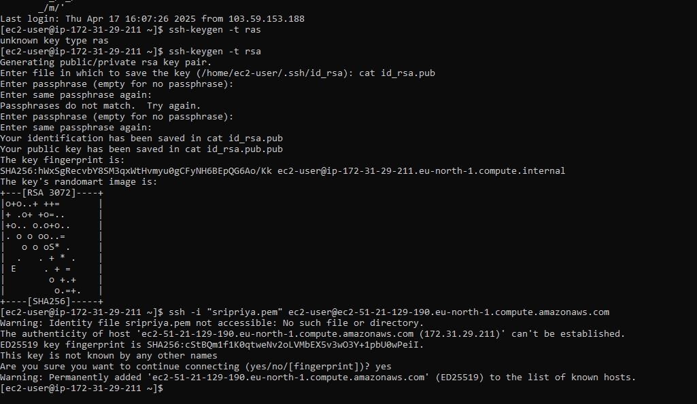
- Monitor log files using tail or grep.
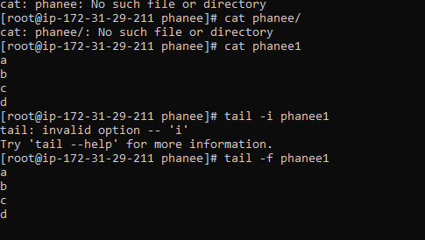
- Set up a web server (e.g., Apache or Nginx).
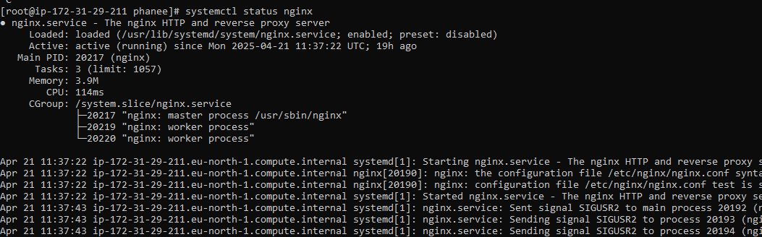
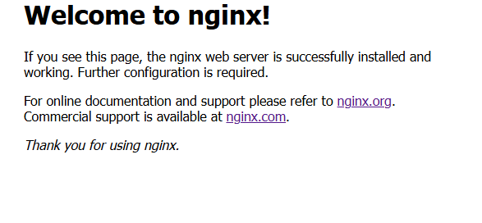
- Configure and secure a MySQL Database.
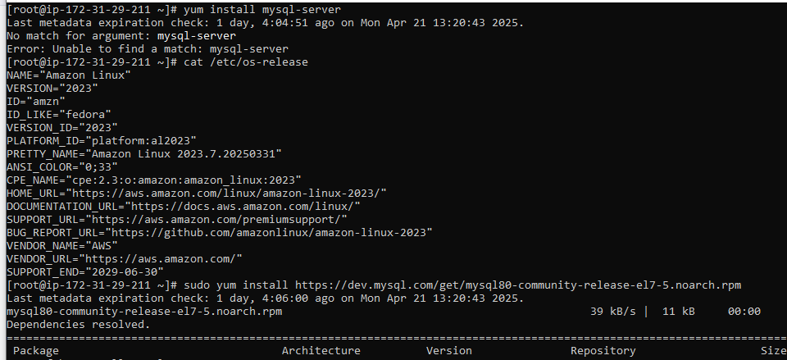

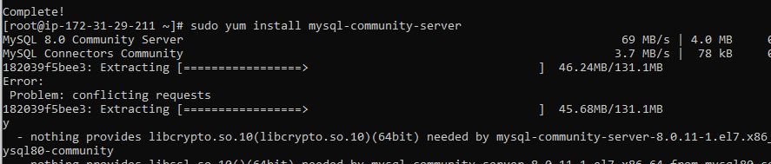

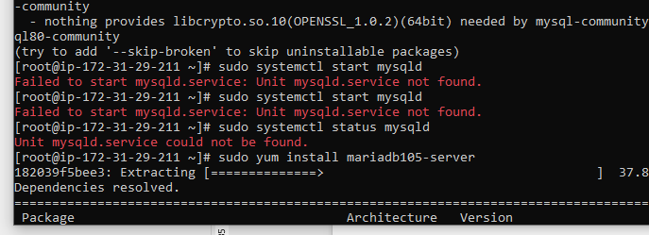

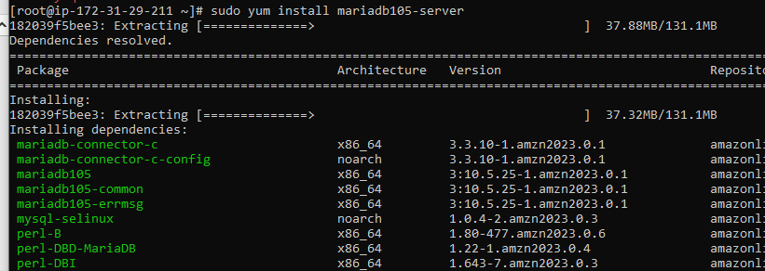

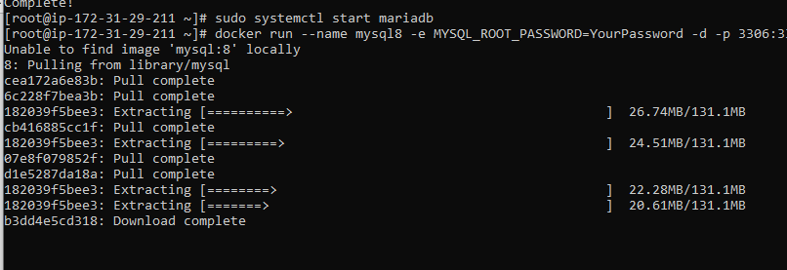

- Set up a Application Server (e.g.,Apache Tomcat)
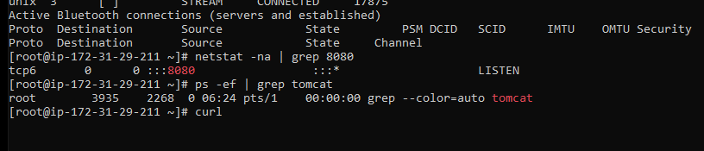

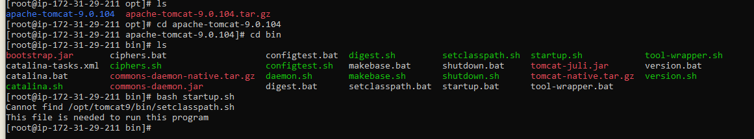

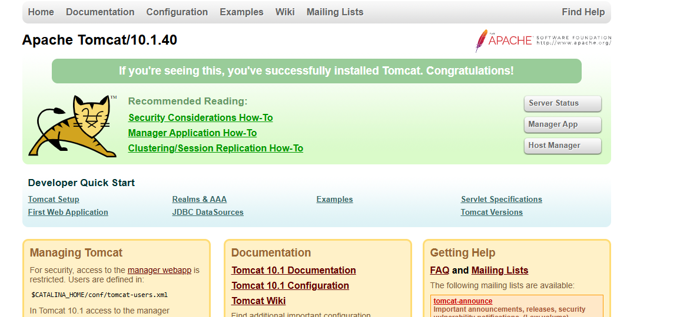

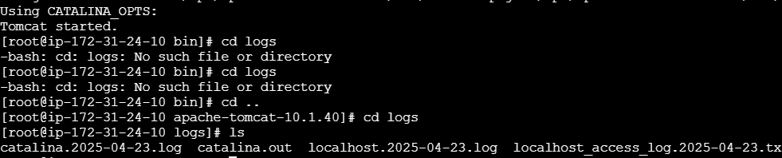

- create a service file for Apache Tomcat.(Should execute by using systemtctl command)

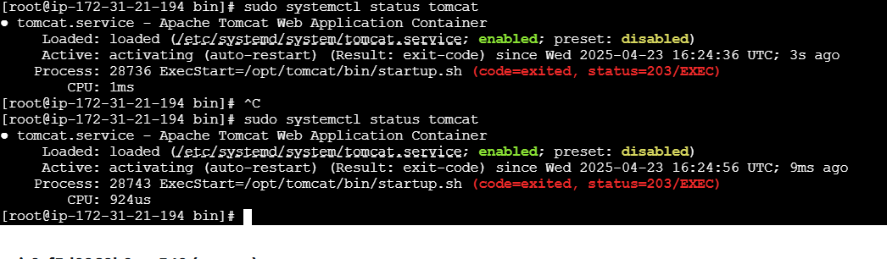

- Print specific columns from a delimited file.
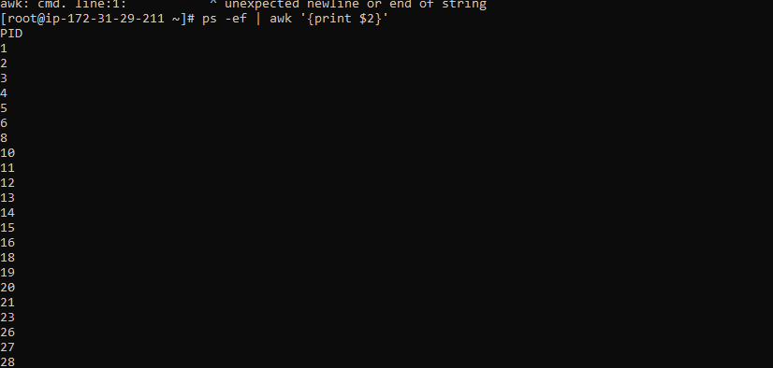
- Filter and print lines based on a specific pattern or condition.
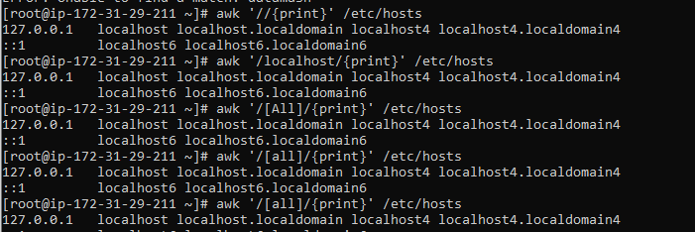
- Calculate and print the average, sum, or other statistics of a column.

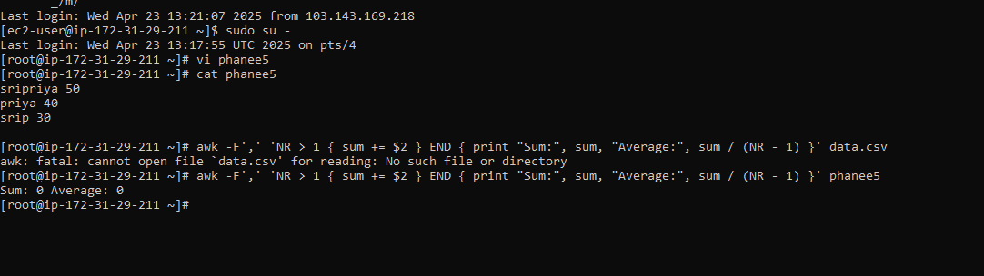

- Perform string manipulation, such as extracting substrings or changing case.
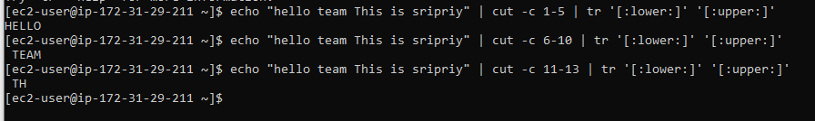
- Count the occurrences of a specific pattern in a file.
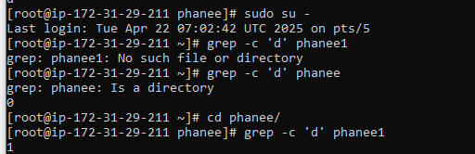
- Sort lines based on a specific field or column.
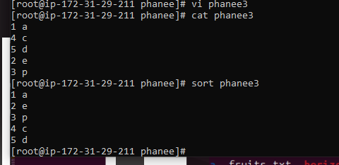
- Merge multiple files based on a common field or column.
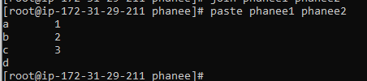
- Substitute text in a file using search and replace.
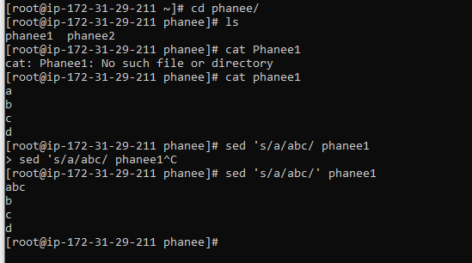
- Delete specific lines based on a pattern or line number.
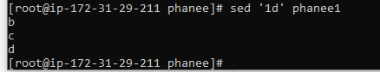
- Append or insert text before or after a specific pattern or line.
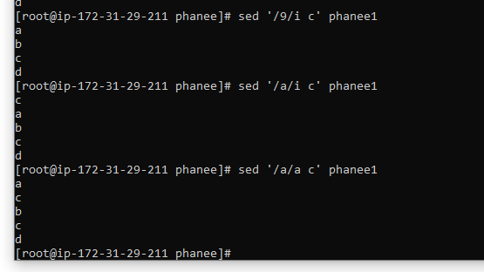
- Print only specific lines from a file.
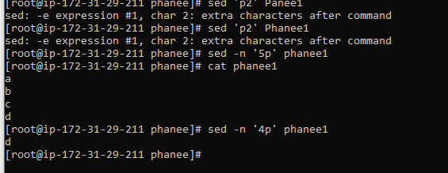
- Copy file from linux to windows machine

scp -i sripriya.pem ec2-user@51.21.253.166:/home/ec2-user/sripriya.txt C:/sripriya/

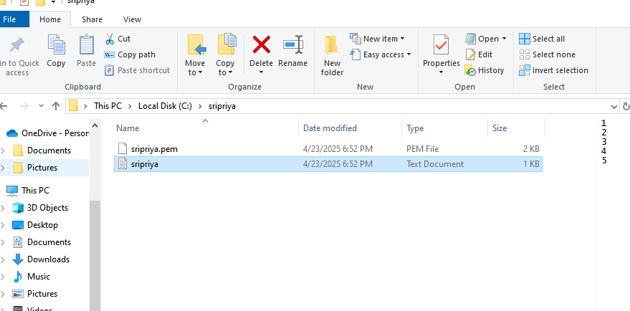
- 5 use cases for AWK and 5 use cases for sed
AWK
1)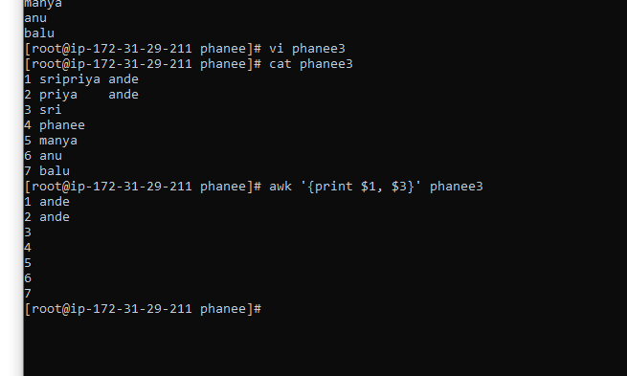
2)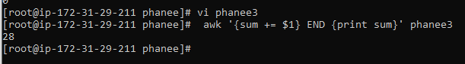
3)
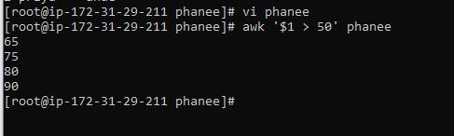
4)
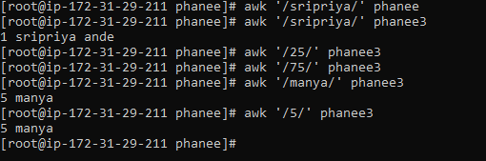

5)
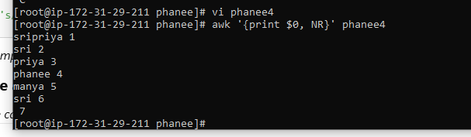

Sed
1)
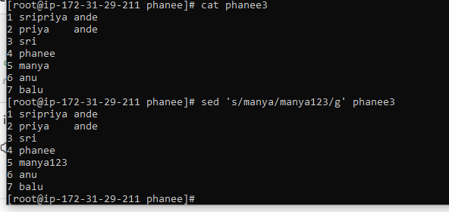
2)
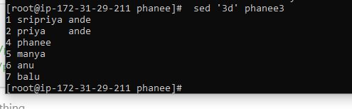

3)

3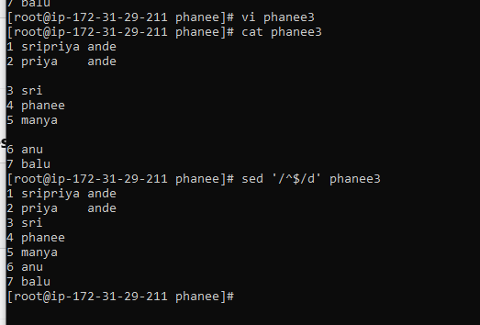
4)
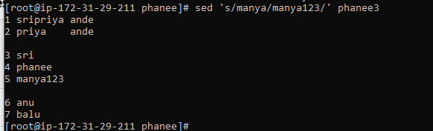
5)
